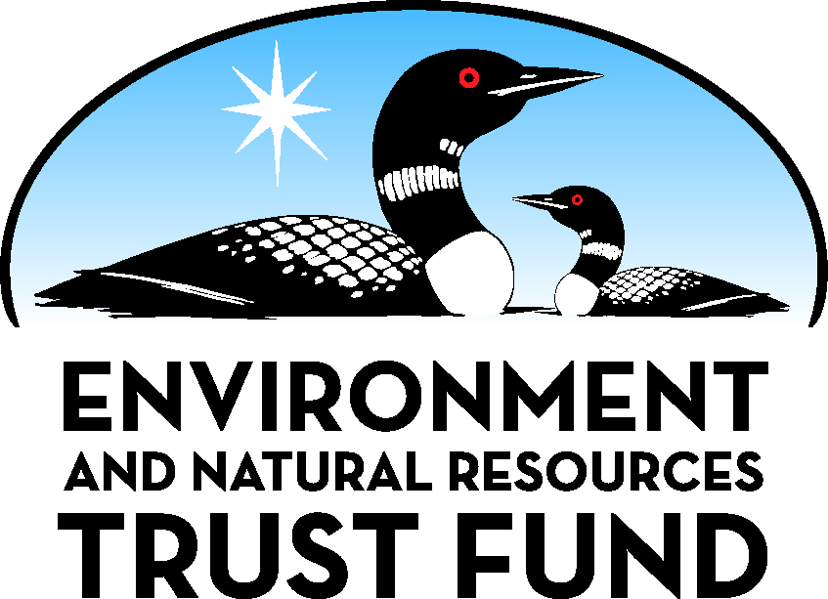 | Environment and Natural Resources Trust Fund (ENRTF)  2020 Main Proposal  Project Title: Developing strategies to manage PFAS in land-applied bio-wastes

Project Manager Qualifications/Organization: Minnesota Pollution Control Agency

Project Manager

Summer Streets is a research scientist in the Environmental Analysis and Outcomes Division of the Minnesota Pollution Control Agency. She will be lead technical administrator for the project with responsibility for MPCA’s portion of the study and overseeing management, project reporting, and contracting. Since 2008, Summer has successfully developed and conducted several complex studies on environmental contamination of PFAS in Minnesota. Staff in the Environmental Analysis and Outcomes Division have extensive experience studying environmental contamination, and managing large project budgets, including LCCMR-funded projects.

Qualifications

Education:

M.S. 2012 University of Minnesota (Water Resources Science)
B.S. 2005 University of Wisconsin-River Falls (Environmental Science and Biology)

Work Experience:

2007-Present Research Scientist 3, Minnesota Pollution Control Agency
2016 – Present Adjunct Faculty, University of St. Thomas, Department of Biology

Organization Description

The Minnesota Pollution Control Agency’s mission is to protect and improve the environment and enhance human health. The MPCA monitors environmental quality, offers technical and financial assistance, and enforces environmental regulations.

